**Instance-2 connected to network-2(subnet-b)**

1. Once you first log in, your screen should look similar to this.

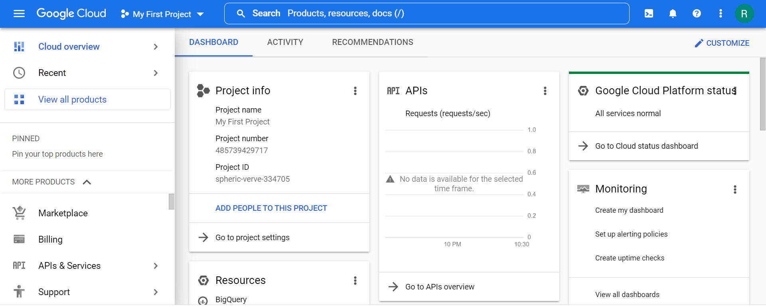

1. Click on the project selector drop-down menu at the top of the screen.

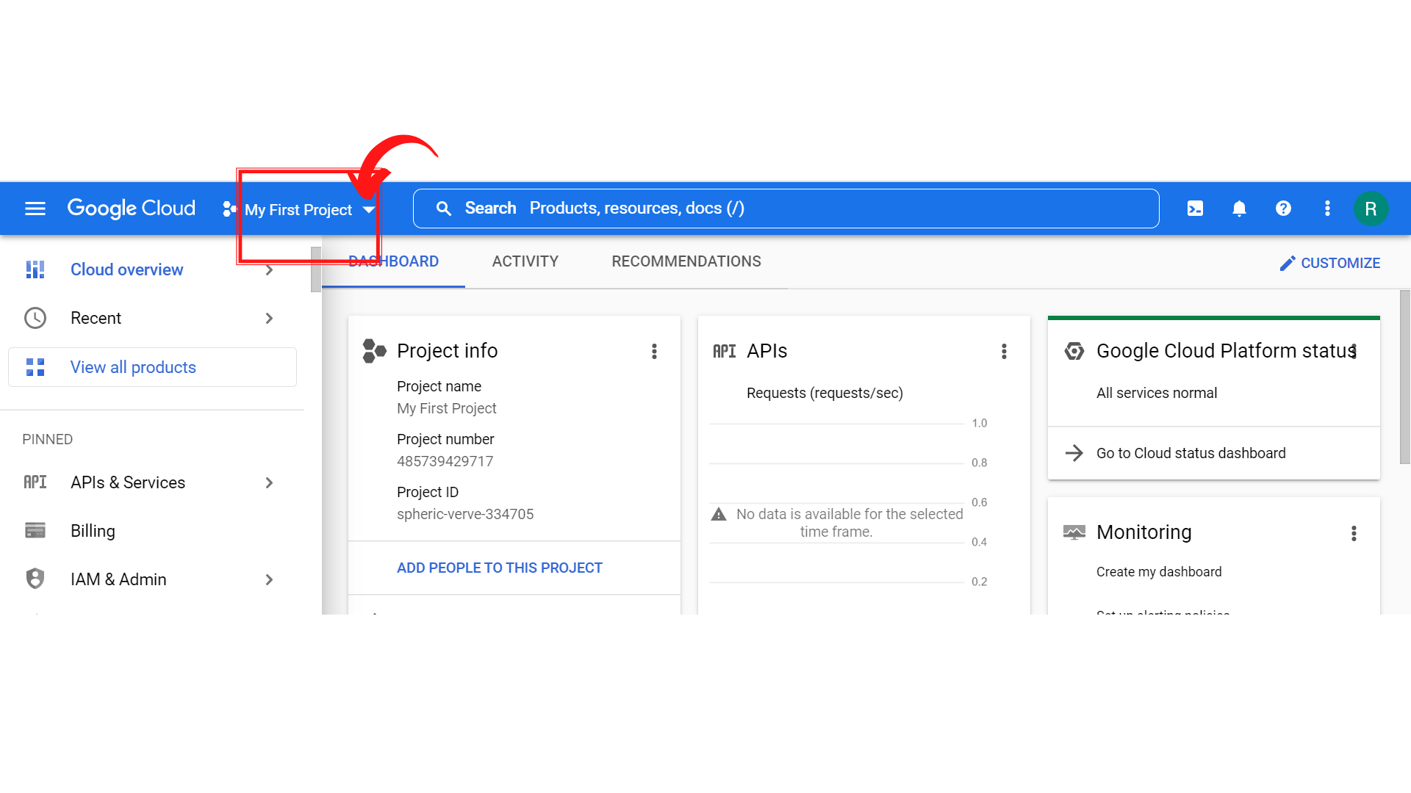

1. Since, we are doing labs on a Security Labs project, Click on *“Security Labs”*.

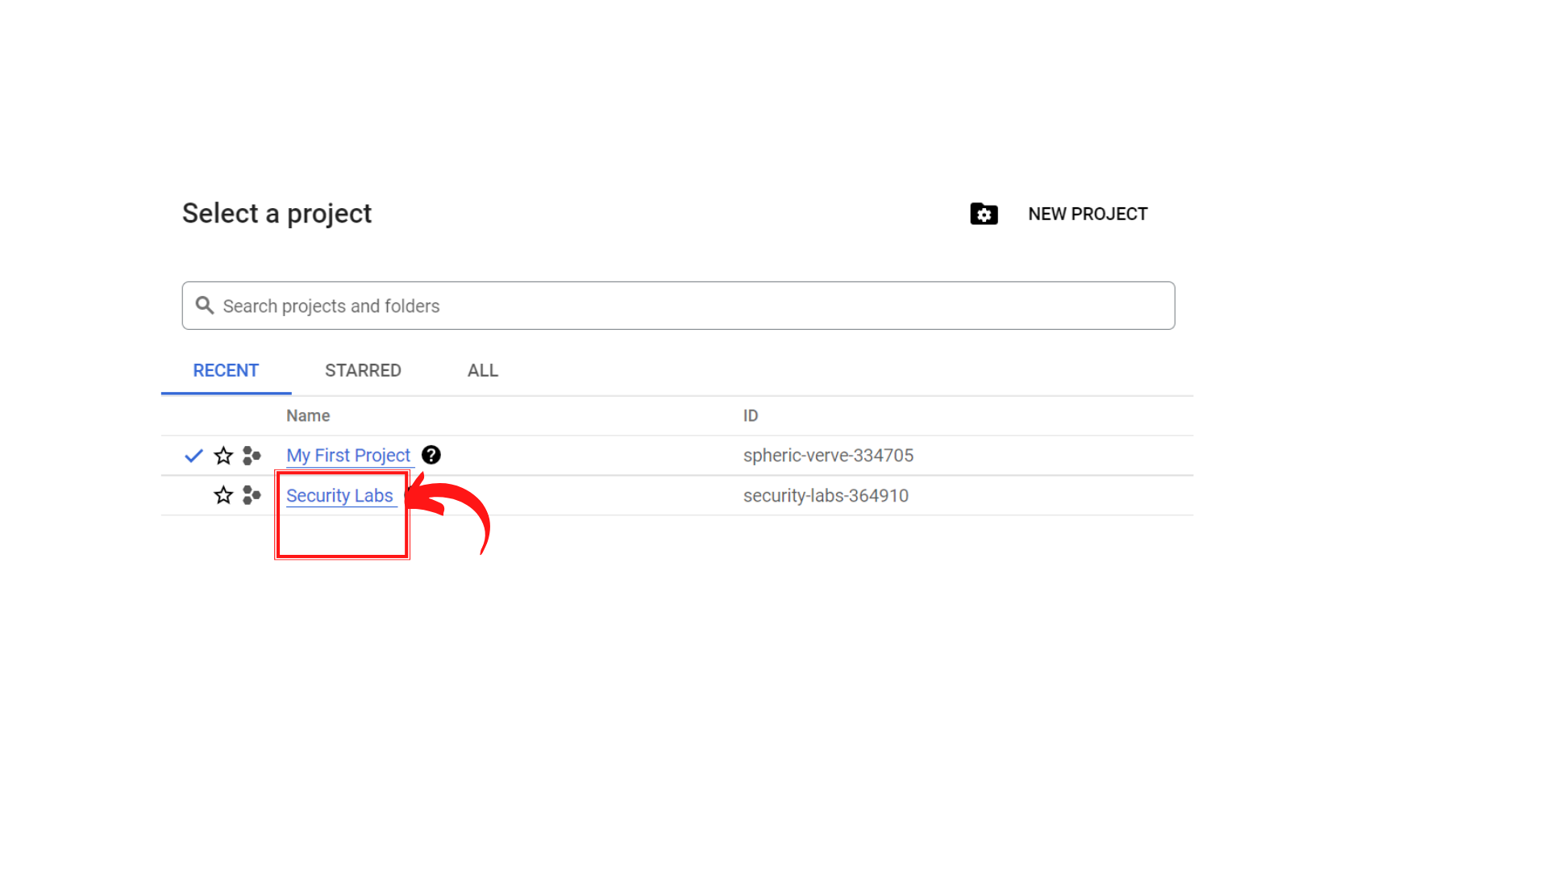

1. Your screen should look similar to this with project info changed to “*Security Labs”* project.

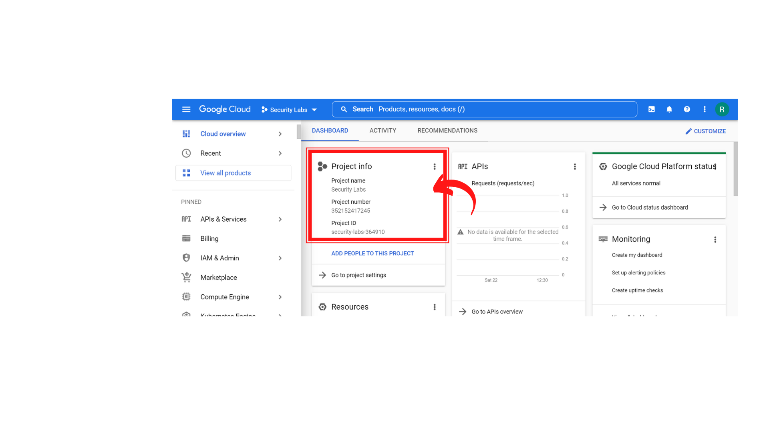

1. To create a new VM instance-1, click on *“Compute Engine → VM instances.”*

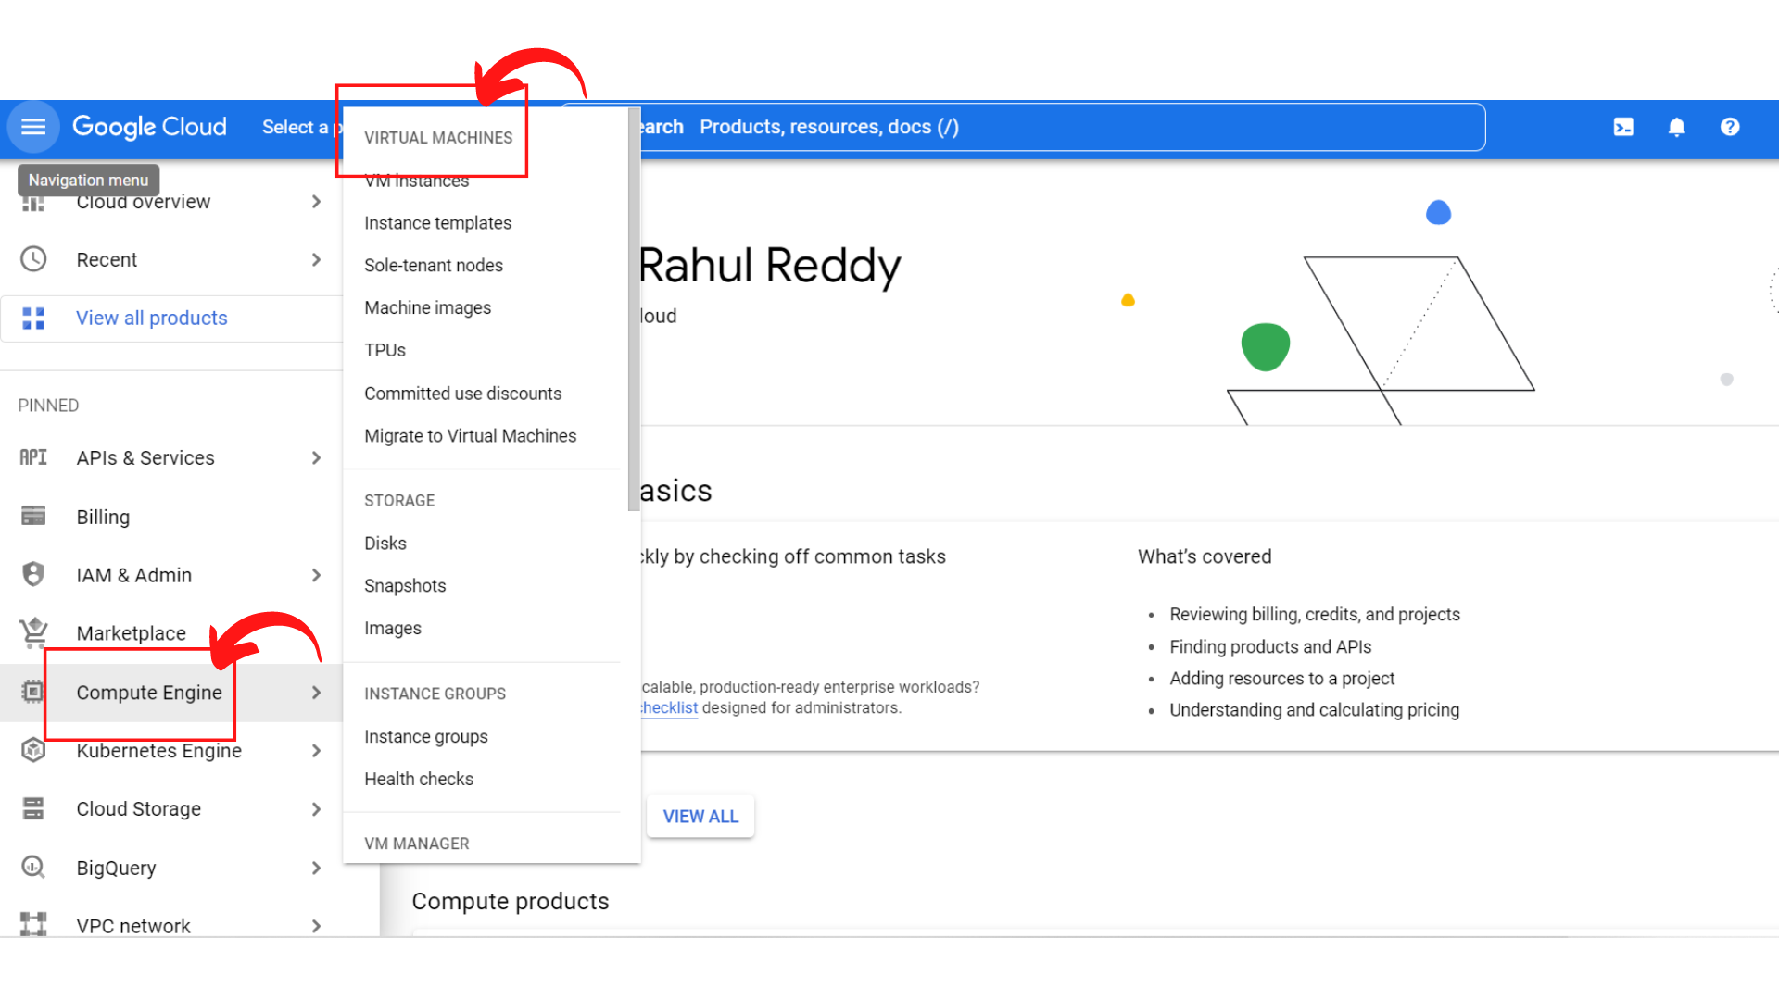

1. Your screen should look similar to this if your *“Compute Engine API”* is not enabled.

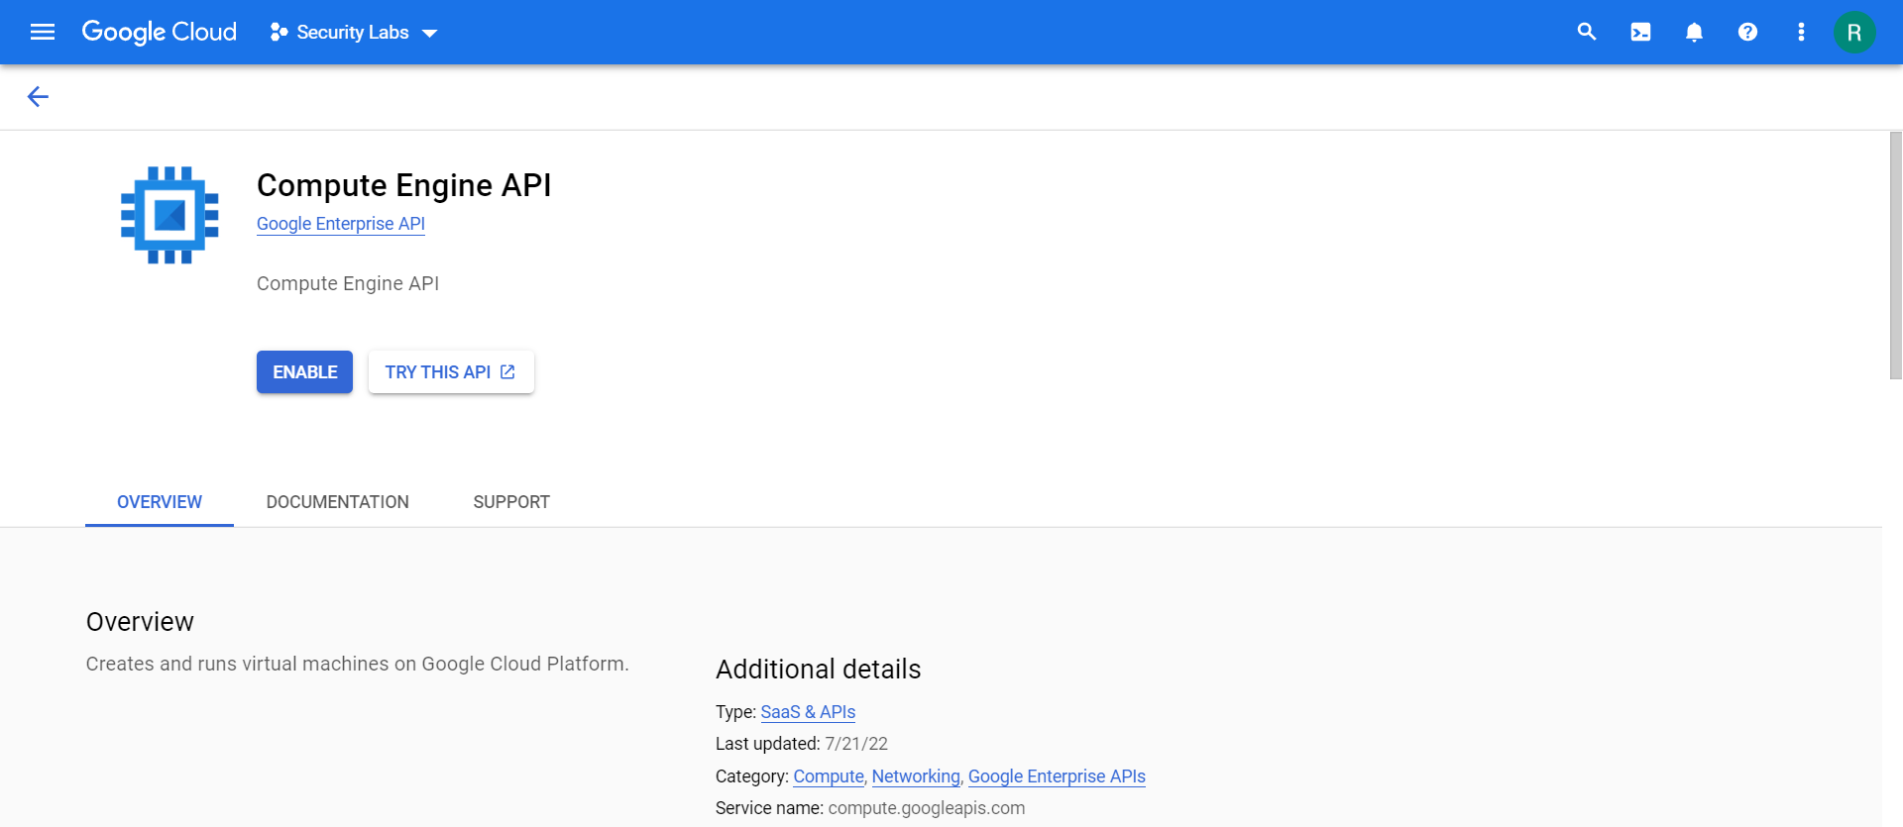

1. Click on *“Enable”*

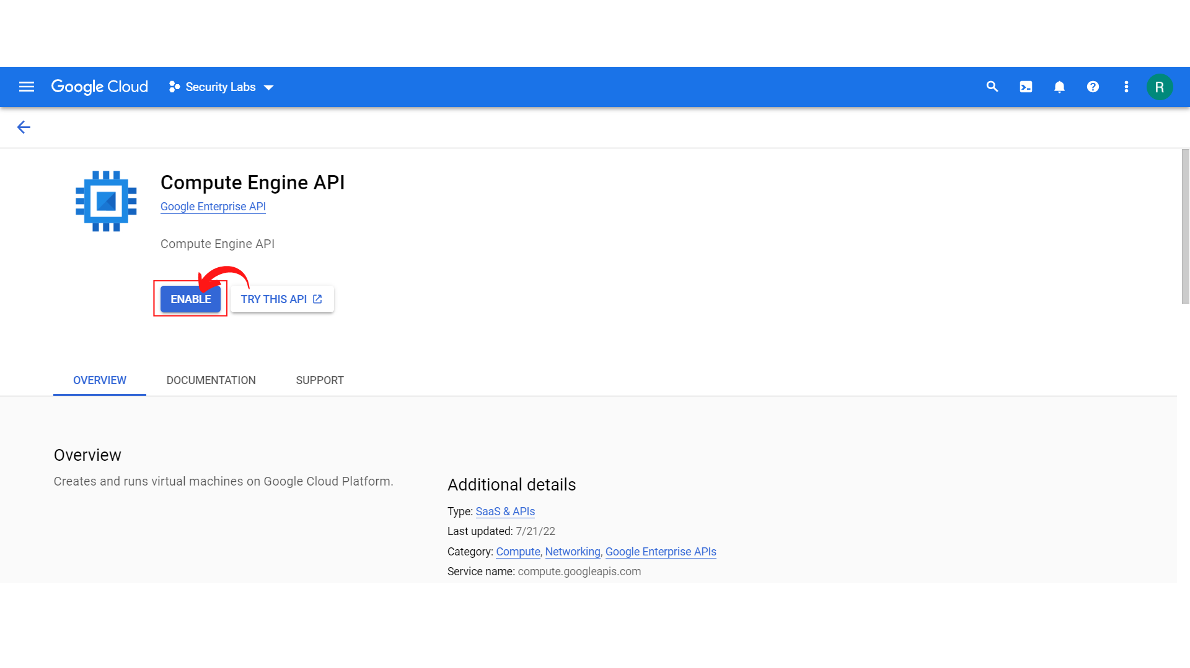

1. Once the Compute Engine API is enabled, your screen should look similar to this.

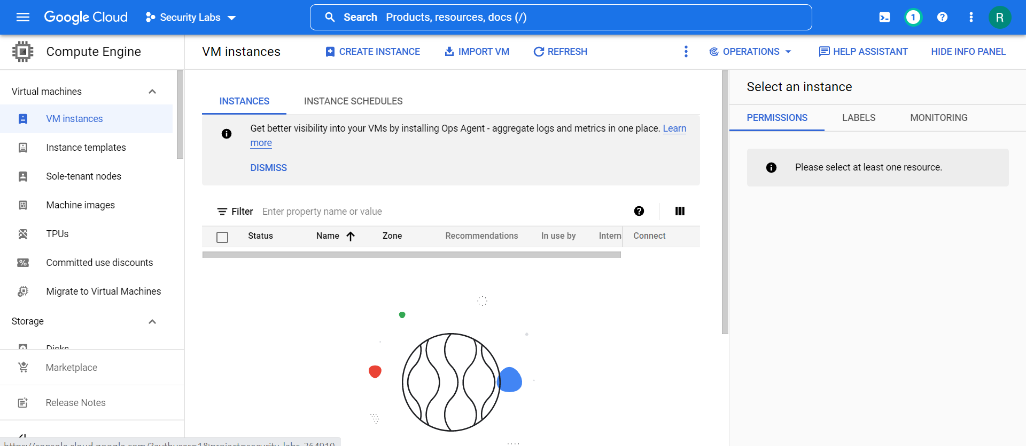

1. Click → “*Create Instance”*

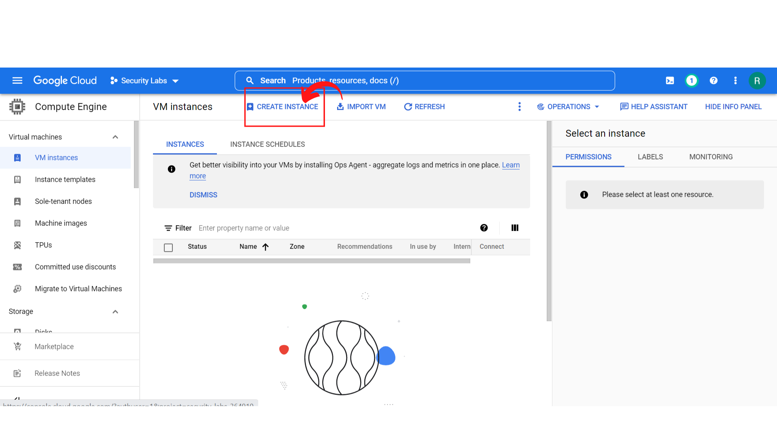

1. Your screen should look similar to this.

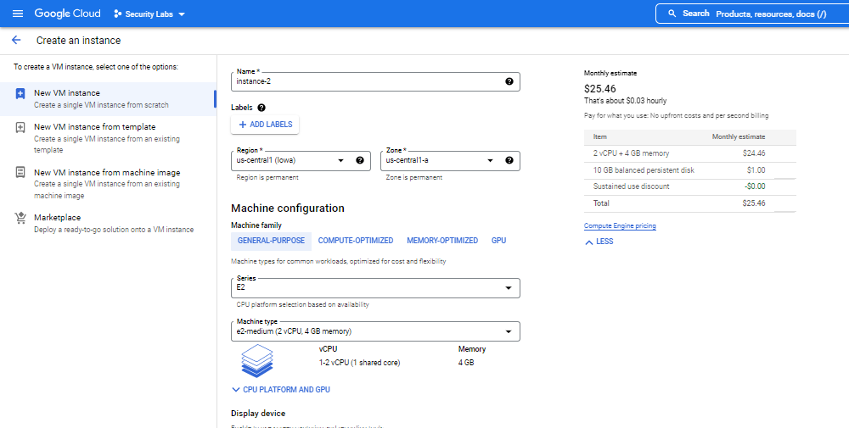

1. Enter the *Instance name as “****instance-2”****,*  and *choose your* ***“Region → us-west2 (Los Angeles)” and “Zone → us-west2-a” and Leave all settings as default.***

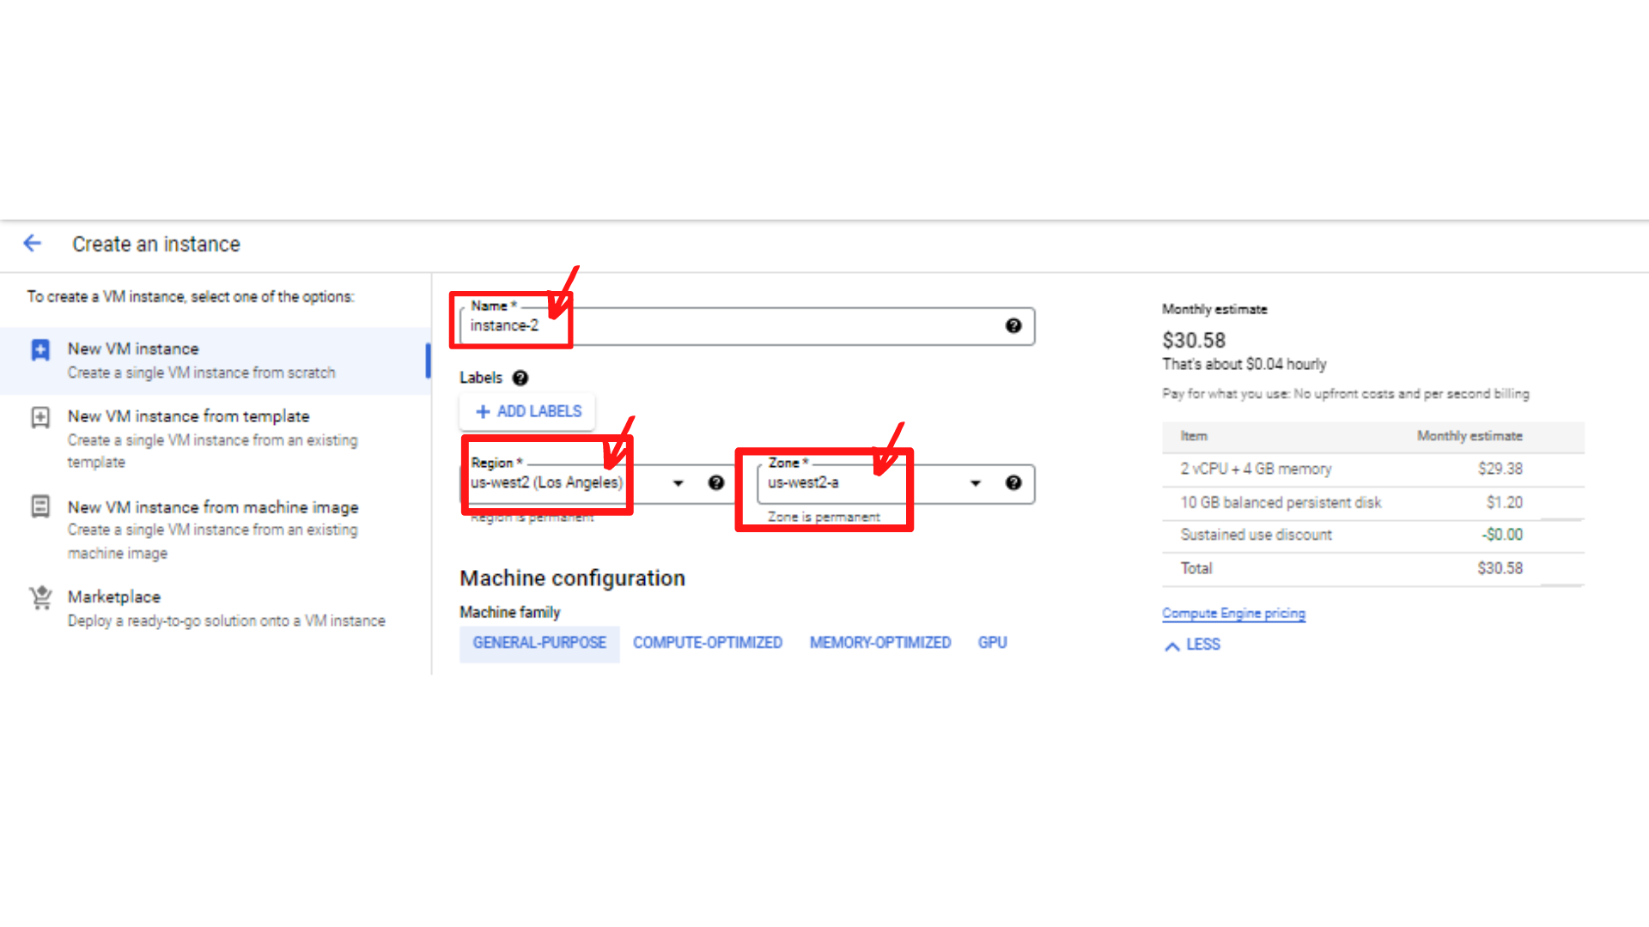

1. Now scroll down, until you see the Advanced options, ***“Click → Advanced Options”***.

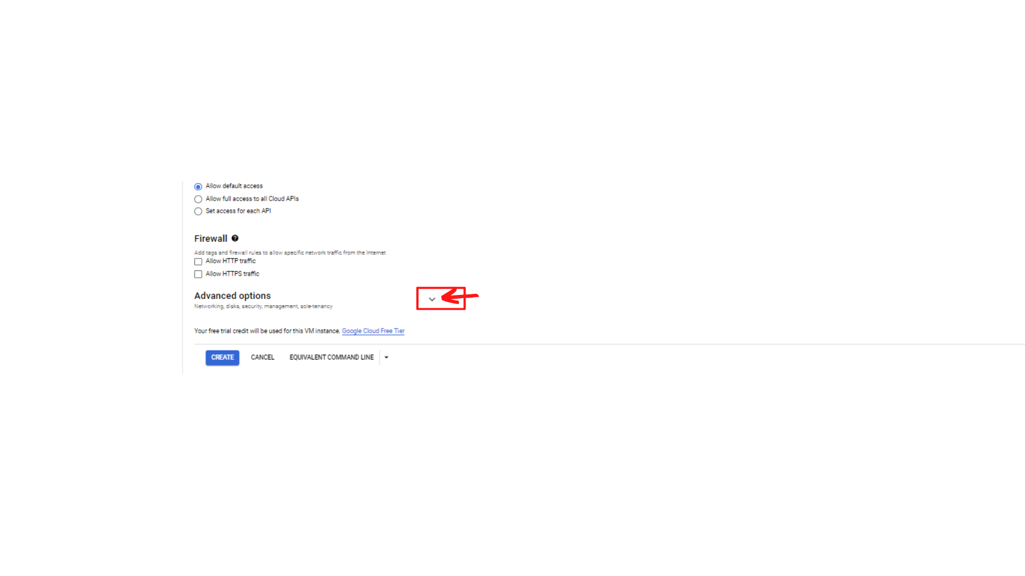

1. You will see the drop-down with additional options like Networking, Disks, Security, Management and Sole-tenancy. ***“Click→ Networking”***

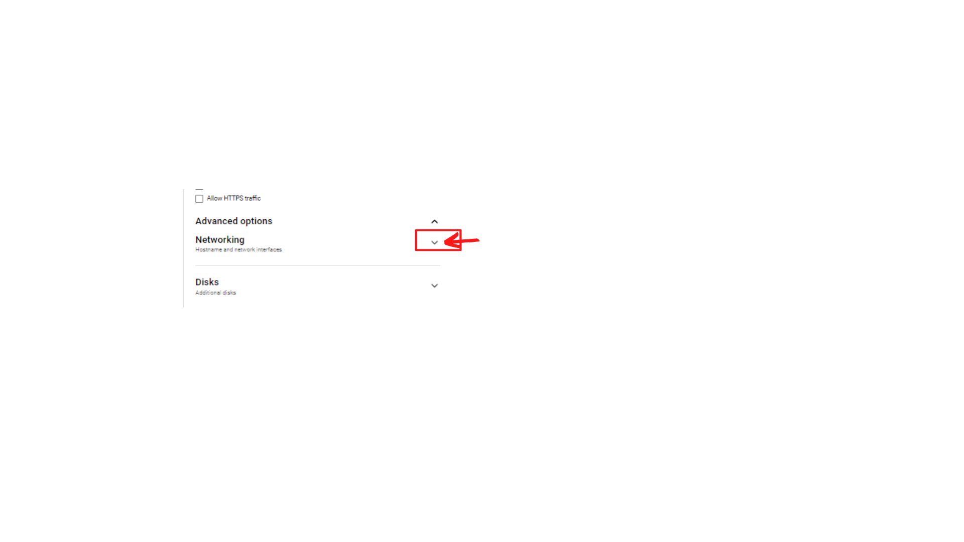

1. Your screen should look similar to this with Networking Form. “***Click → Network interfaces”***

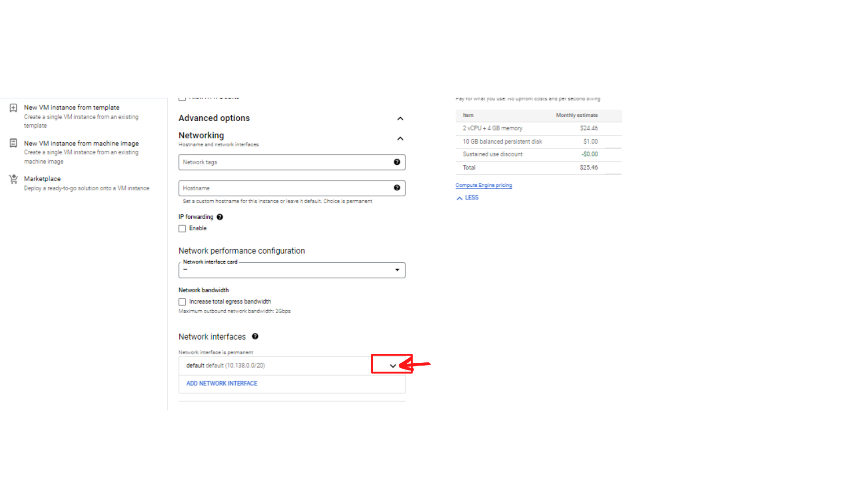

1. Now your screen should look like this with ***“Edit network interface”*** Form:

Enter the following information.

**Network : *Change from default to “network-2”***

**Subnetwork: Select *“subnet-b”***

**Primary Internal IP: select “*Ephemeral (Custom)”***

**Custom ephemeral IP address :** Enter ***“10.0.2.2”***

Then ***“Click → Done”***

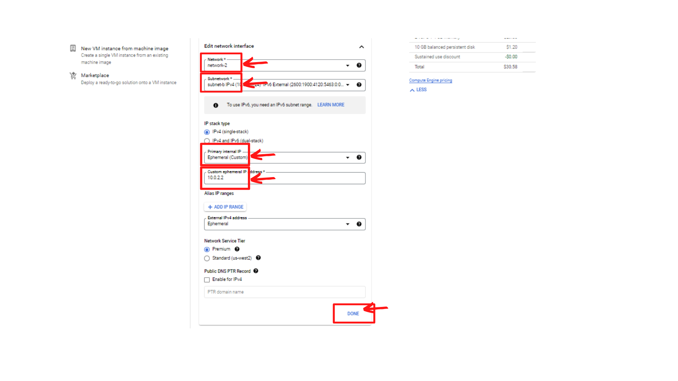

1. Now scroll down and ***“Click → Create”***

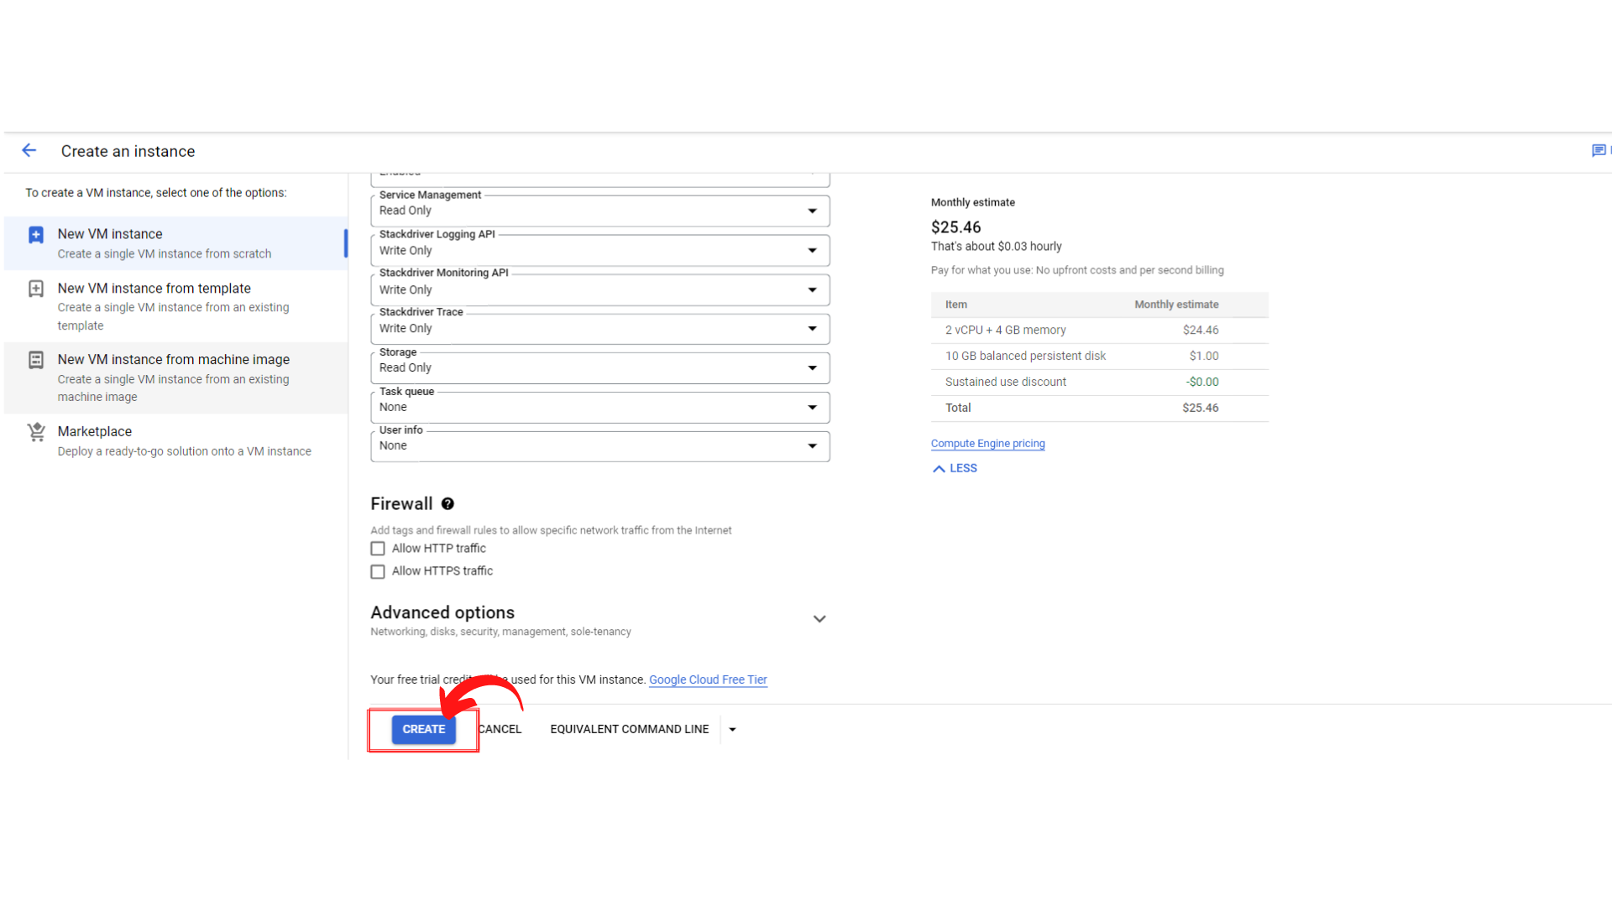

1. Now your screen should look like this with status → “Green Color Tick Mark”. That means your instance is running.

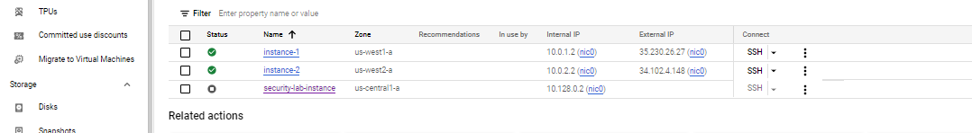

1. That’s it, you have successfully created your instance-2 connected to network-2(subnet-2).

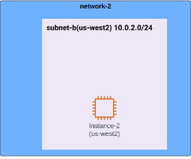

1. Now check the SSH connection by ***“Clicking → SSH”***. this will open a new browser window with SSH-in-browser.

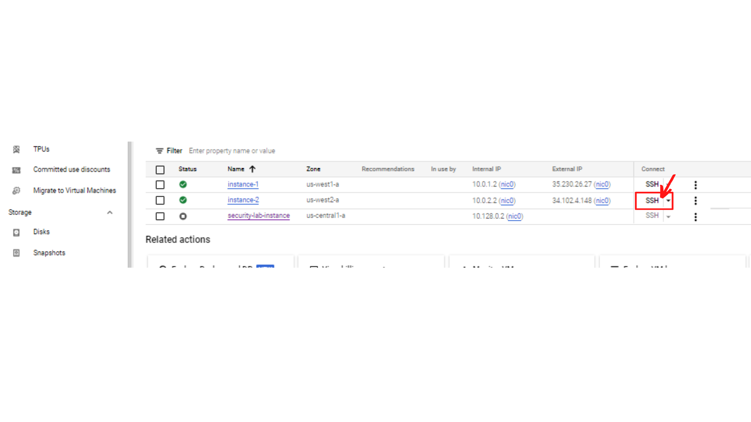

1. Your screen should now look like this since VM is unable to connect port 22.

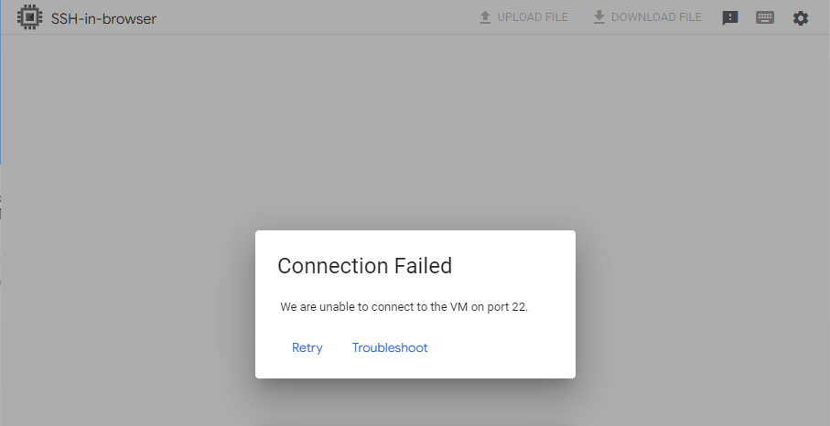

1. In order to connect to SSH, you need to add a firewall rule for network-2. There is a separate document to create firewall rules for network-2.